Spring Framework is a Java platform that provides comprehensive infrastructure support for developing Java applications. Spring handles the infrastructure so you can focus on your application.
Spring enables you to build applications from “plain old Java objects” (POJOs) and to apply enterprise services non-invasively to POJOs. This capability applies to the Java SE programming model and to full and partial Java EE.
Although the Java platform provides a wealth of application development functionality, it lacks the means to organize the basic building blocks into a coherent whole, leaving that task to architects and developers. True, you can use design patterns such as Factory, Abstract Factory, Builder, Decorator, and Service Locator to compose the various classes and object instances that make up an application. However, these patterns are simply that: best practices are given a name, with a description of what the pattern does, where to apply it, the problems it addresses, and so forth. Patterns are formalized best practices that you must implement yourself in your application.
The Spring Framework Inversion of Control (IoC) component addresses this concern by providing a formalized means of composing disparate components into a fully working application ready for use. The Spring Framework codifies formalized design patterns as first-class objects that you can integrate into your own application(s). Numerous organizations and institutions use the Spring Framework in this manner to engineer robust, maintainable applications.
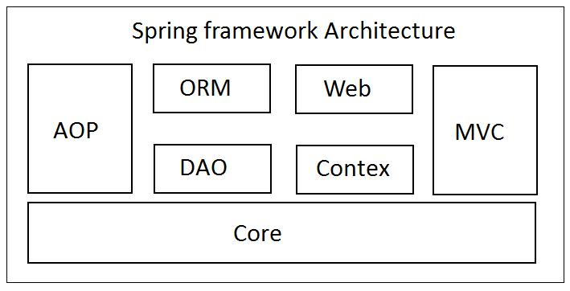
The Spring Framework consists of the following modules. These modules are Spring Core, Spring AOP, Spring Web MVC, Spring DAO, Spring ORM, Spring context, and Spring Web Flow.

